SCHOOL OF COMPUTER SCIENCE AND ARTIFICIAL INTELLIGENCE |  |  |  |  | DEPARTMENT OF COMPUTER SCIENCE ENGINEERING
Program Name: B. Tech |  |  |  | Assignment Type: Lab |  |  | Academic Year:2025-2026
Course Coordinator Name |  |  |  | Venkataramana Veeramsetty
Instructor(s) Name |  |  |  | Dr. V. Venkataramana (Co-ordinator)  Dr. T. Sampath Kumar  Dr. Pramoda Patro  Dr. Brij Kishor Tiwari  Dr.J.Ravichander  Dr. Mohammand Ali Shaik  Dr. Anirodh Kumar  Mr. S.Naresh Kumar  Dr. RAJESH VELPULA  Mr. Kundhan Kumar  Ms. Ch.Rajitha  Mr. M Prakash  Mr. B.Raju  Intern 1 (Dharma teja)  Intern 2 (Sai Prasad)  Intern 3 (Sowmya)  NS_2 ( Mounika)
Course Code |  |  | 24CS002PC215 | Course Title |  | AI Assisted Coding
Year/Sem |  |  | II/I | Regulation |  | R24
Date and Day  of Assignment |  |  | Week7 - Monday | Time(s)
Duration |  |  | 2 Hours | Applicable to  Batches
AssignmentNumber:13.5(Present assignment number)/24(Total number of assignments)
 | Q.No. | Question |  |  |  |  |  | Expected Time  to complete
 | 1 | Lab 13: Code Refactoring – Improving Legacy Code with AI Suggestions  Lab Objectives:  - Identify code smells and inefficiencies in legacy Python scripts.  - Use AI-assisted coding tools to refactor for readability, maintainability, and performance.  - Apply modern Python best practices while ensuring output correctness.  Task 1: Refactoring a Legacy Calculator Script  Scenario:  A university has a legacy Python script for a basic calculator that uses long, repetitive if-else statements for each operation. The code is difficult to maintain.  - Upload the calculator script to a GitHub repository.  - Use GitHub Copilot to suggest a more modular and cleaner version (e.g., functions, dictionary-based mapping).  - Compare the AI-suggested refactoring with the original code and document improvements.  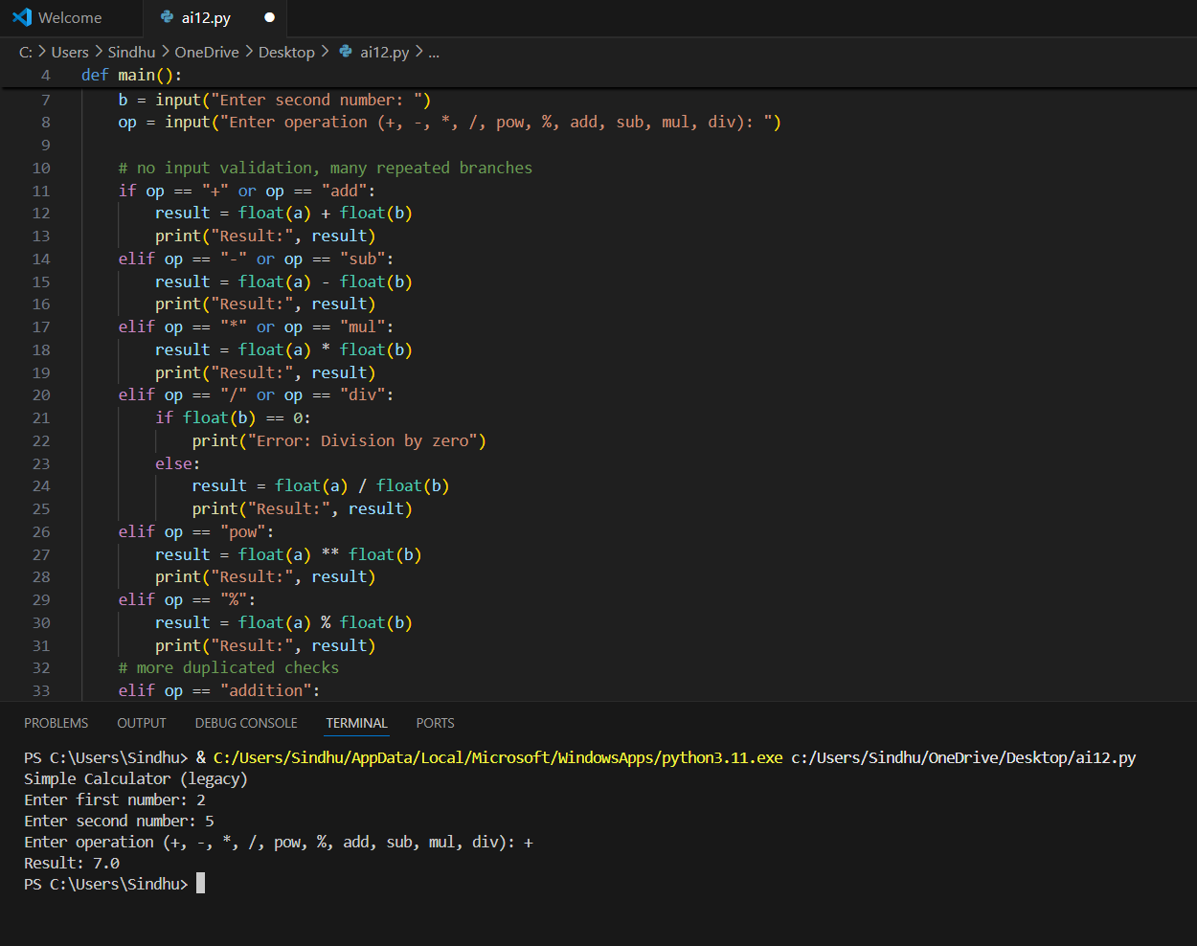  Task 2: Modernizing a Student Database Program  Scenario:  An old student management program uses procedural code with global variables and no error handling. The program frequently crashes when handling incorrect inputs.  - Push the legacy code into your GitHub repo.  - Ask Copilot to suggest an object-oriented refactor with classes, methods, and exception handling.  - Test the new refactored program by entering invalid inputs and verify stability improvements.  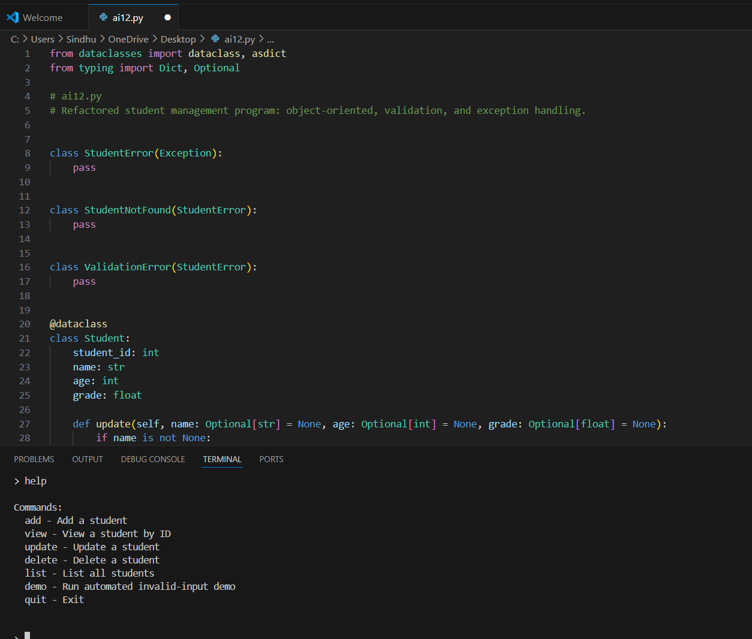  Task 3: Optimizing Performance in File Processing  Scenario:  A company’s file-processing script reads large log files line by line using inefficient loops, causing delays.  - Commit the original file-processing script to GitHub.  - Use Copilot suggestions to replace inefficient loops with more optimized approaches (e.g., list comprehension, built-in functions, generators).  - Compare the execution time of legacy vs. refactored versions and document the performance gains.  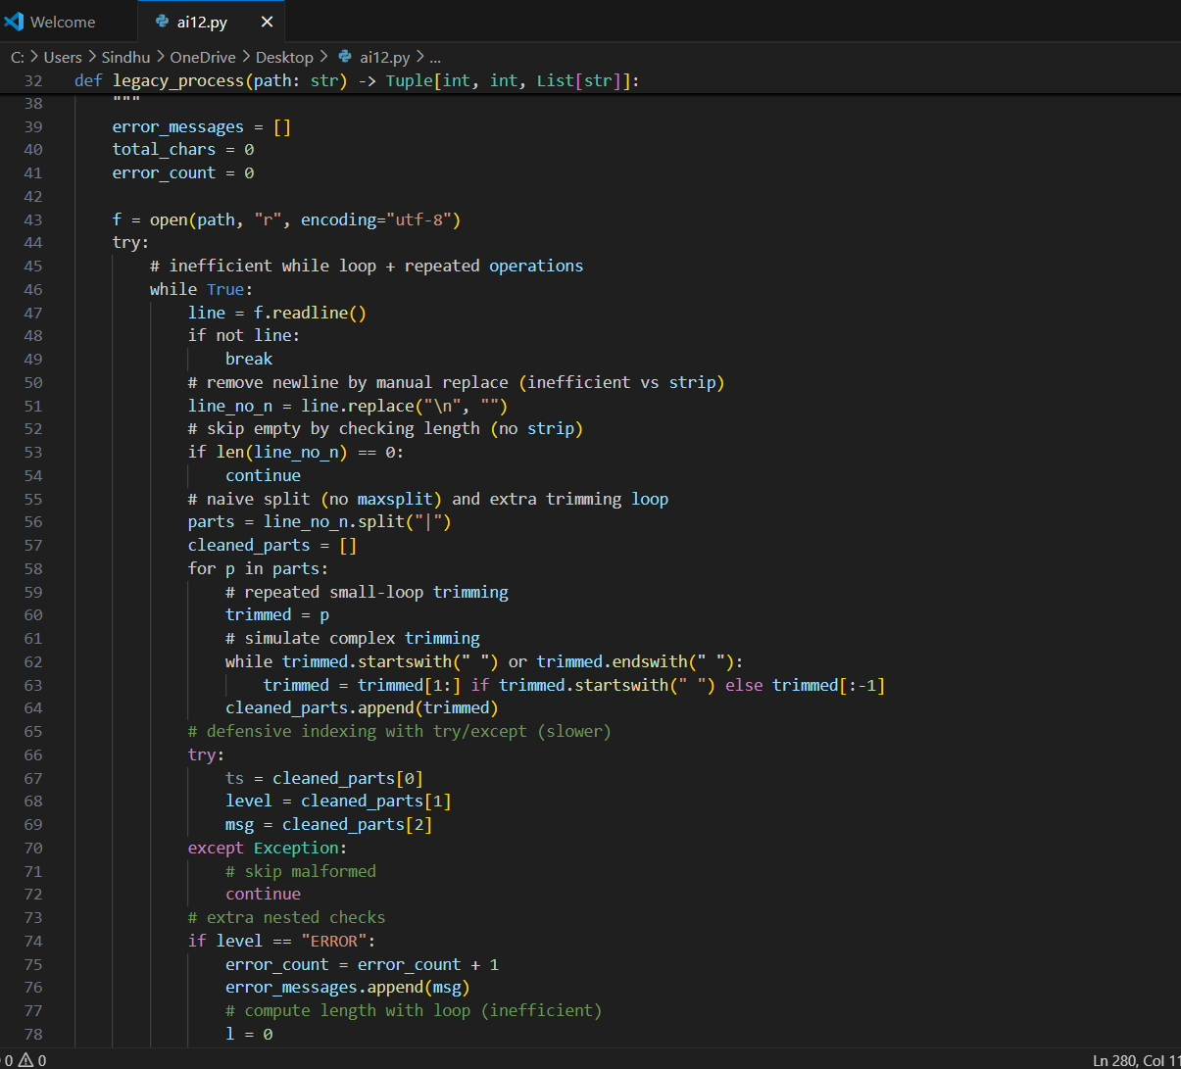  Task 4: Enhancing Readability and Documentation  Scenario:  A research group has shared a scientific computation script with minimal comments, inconsistent naming, and poor readability.  - Upload the legacy code to GitHub.  - Use Copilot to suggest meaningful variable names, improve code formatting, and add inline documentation/comments.  - Generate an AI-assisted README.md file for the project explaining usage, inputs, and outputs.  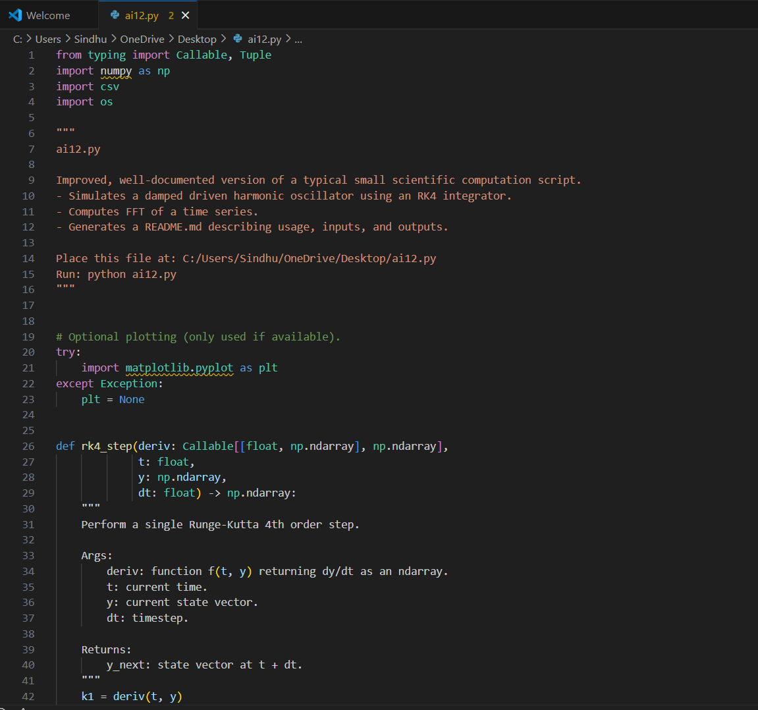 |  |  |  |  |  | Week 7 - Friday

